2024
STRATEGIC IMPROVEMENT PLAN

St Pius X High School, Adamstown

Definitions

CSO Strategic Plan
The CSO Strategic Plan provides the long-term strategic intent for Maitland-Newcastle schools and does not specify or prescribe the goals and actions for improvement for system schools. Schools are encouraged to align with CSO goals, recognising that schools may also have goals arising from COSI review recommendations or goals that fit within their context.

School Strategic Plan
The School Strategic Plan (SSP) refers to the one-page three-year plan that the school will develop with system support following the conclusion of a COSI Self Review or External Review, i.e. Year 3 and Year 6 of the cycle. Selected goals and objectives may work across a number of domains and/or objectives. Schools are encouraged to keep their focus narrow and their plans lean.

Strategic Improvement Plan
The Strategic Improvement Plan (SIP) refers to the detailed plan for that calendar year of the school’s cycle and will be derived from the broad directions set in the three-year strategic plan.

Mission, Vision and Guiding Principles
The mission is reviewed and a vision for the future and guiding principles for decision making emerge through research and analysis.

COSI Review Findings
The review process serves to provide the consultation, data gathering and analysis and stakeholder surveying to provide recommendations that set a strong foundation for the strategic planning process. As part of the COSI review process, a range of tools including the NSIT and CIIT are used. Data is collected and synthesised in the context of the system’s mission, vision, and guiding principles and articulated into review findings. In this phase, the review process will document the current state of reality in the context of the school’s mission and vision, as well as stakeholder values and priorities for the school and system’s future. External trends and government regulations are also considered.

Strategic Goals
Strategic goals are extracted from the review findings and recommendations. Strategic goals are broad, long-term aims that operationalise the system and school’s mission and vision into general intentions that reflect the desired future position of the school.

Objectives
The objectives are tangible strategies necessary to accomplish the strategic goals while staying true to the mission, vision, and guiding principles. Strategies may positively impact more than one goal area.

Implementation Strategies and Actions
Upon approval of the strategic plan, specific actions and timelines necessary to achieve the goals and objectives are developed. Research shows that 90 percent of organisations fail to successfully implement their strategies, so this step is critical. Lasting success can be achieved through focusing on the right actions and staying with them. It is the role of the school, with system support, to develop annual implementation plans that delineate the steps and timelines necessary to achieve the goals (see School Improvement Plan template).

Execution
After the implementation plan is finalised, the school should develop systems necessary to monitor adherence to the plan, including the development of a simple dashboard to highlight progress on key performance indicators linked to the strategic plan, i.e. PL and PP&D plans.

SCHOOL STRATEGIC PLAN GOALS 2023-2025

Goal 1: Catholic Culture and Mission
To nurture a truly sacramental Catholic school community that lives the Gospel through faith expressed in action.

Goal 2: Formation
To offer formation opportunities that inspire and build the capacity of staff, students and families to deepen their relationship with Jesus and their willingness to live and proclaim the Good News to the world.

Goal 3: Religious Education
To foster the integration of faith and life using creative and engaging opportunities in Religious Education.

Goal 4: Student Centred Learning
For each learner to learn where, when and how they work best, and be empowered to participate in decision-making about their learning and wellbeing.

Goal 5: Effective Classroom Learning
To build the capacity of educators to ensure that all students are known, their strengths are recognised and accommodated, diversity is celebrated, and each learner demonstrates growth.

Goal 6: Adaptive and Innovative Learning
To equip learners with the analytical, cognitive, digital, and social competencies that enables them to fully engage with and contribute to our changing world.

Goal 7: Leadership Capacity and Culture
To build the capacity and opportunity of every teacher to lead across a range of domains.

Goal 8: Leadership Succession
To foster a collaborative culture and enable aspiring leaders to develop skills across a range of domains.

Goal 9: Student Leadership
To foster and cultivate leadership qualities across the student body.

Goal 10: Wellbeing
To ensure school initiatives enhance wellbeing and resilience and are complemented by measures to promote a culture of inclusivity.

Goal 11: Promoting Positive Partnerships
To build and strengthen partnerships with families, parishes, community and industry agencies.

Goal 12: Responsibility for Learning
Students to be active participants in their own learning and wellbeing, to feel connected and to use their social and emotional skills to be respectful, resilient and safe.

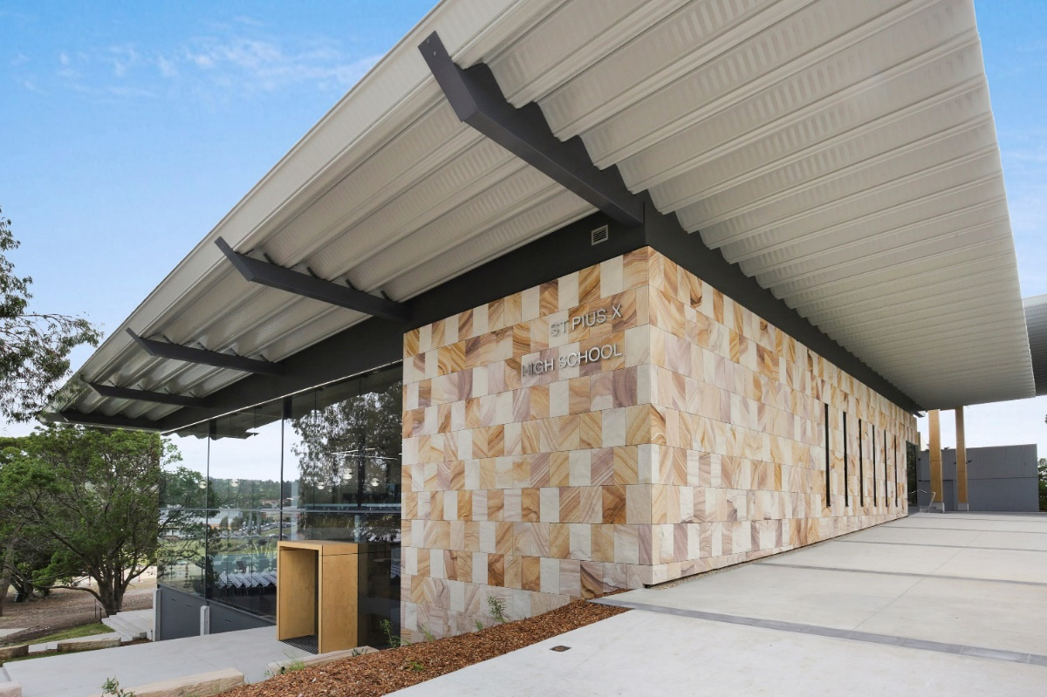

DOMAIN 1 – CATHOLIC FORMATION AND MISSION

SCHOOL GOALS | CSO GOALS | ACTIONS TO SUPPORT GOALS | APST | WEEK/TERM  COMPLETION | LEADER | OTHER STAFF | EVIDENCE OF IMPACT
Goal 1 Catholic Culture and Mission | 1 | Immerse the school community in the characteristics of the Trinity.  Explore opportunities for structured parish connections. | NA | End of Term 4  End of  Term 2 | MC | MC  RSC | Staff leadership and participation in Ministry  A clear program of collaborative events
Goal 2  Formation | 2 | Facilitate staff participation in formation to meet the AWTL requirements and for spiritual nourishment.  Target appropriate formation opportunities for the Religious Education Faculty and middle leaders to meet accreditation.  - Identify staff who are qualified to teach Religious Education but who may not be currently be teaching in the faculty. | NA | End of Term 4  End of Term 3  End of Term 2 | MC  MC  MC | RSC/other interested or necessary staff | Formation for mission framework.  Professional development applications from staff members.  Attendance and other data related to staff and student engagement.  - Improved AWTL engagement with a particular focus on Middle Leaders and RE Staff
Goal 3 Religious Education | 2 & 3 | - Implement newly composed ‘Encountering the Mystery of God’ programs with Year 7 RE syllabus.  - Refine recently introduced ‘Faith and Life’ Modules with Stage 5 RE  - Ongoing improvement in levels of religious literacy and religious imagination | NA | End of Term 4  End Term 4 | LOL  Whole RE Faculty | RE Faculty | - Inclusion of Liberal Arts pedagogy and resources in registers, learning walks and talks etc.  - Opportunities for student agency  - Differentiation across range in formation from Catechesis to Evangelisation  • Enhanced engagement and performance in coursework, summative assessments, and external testing  • Successful partnerships with:  - local community  - Catholic agencies  - social justice action

DOMAIN 2 – LEARNING

SCHOOL GOALS | CSO GOALS | ACTIONS TO SUPPORT GOALS | APST | WEEK/TERM  COMPLETION | LEADER | OTHER STAFF | EVIDENCE OF IMPACT
Goal 4  Formalise and Implement Learning about Learning Program across all Year groups | Goal 3  For each learner to learn where, when and how they work best, and be empowered to participate in decision-making about their learning and wellbeing | Review and prioritize high impact skills and approaches known to facilitate student understanding about their own leaning and backward mapping.  PL for teachers on teaching skills.  Preparation of lessons about selected skills  Implementation of scheduled time across all Years | 1.2.2 | Term 1  Terms 1-4  Terms 1-4  Terms 1-4 | Stephen | Leaders of Learning and others | Students can identify strategies and resources available.  Students better able to discuss aspects of their own learning with specific reference to recent focus lessons.  A learning schedule implemented across the school.
Goal 5  For all students to demonstrate growth in core literacy skills of writing and reading. | Goal 4  To build the capacity of educators to ensure that all students are known, their strengths are recognised and accommodated, diversity is celebrated, and each learner demonstrates growth. | Collaborative assessment of student writing sample in staff meetings. Think. Pair. Share.  PL snacks  Faculty resources for the reading/writing focus within each unit  Tracking student results across various assessments (PAT, tasks, NAPLAN, HSC minimum Standards)  Band analysis with examples | 2.1.2  2.5.2  3.6.2  5.1.2  5.2.2  5.3.2  6.2.2 |  | Leaders of Learning  Pedagogical Partner | Pedagogical Partner | Use of school writing continuum, along with related strategies and posters for both reading and writing, by teachers and students in classrooms during observations and learning walks and talks  Several 10-minute sessions per semester at staff meetings  90% of students attempting HSC Minimum Standards Writing test reach required standard on first attempt  10% increase in number of students achieving band 4 in HSC Minimum Standards Tests
Goal 6  - To ensure all teachers are aware of the requirements for Stage 6 and the successful completion of the HSC  - Teachers of Stage 6 courses To build the capacity of educators to ensure that courses in Stage 6 reflect best practice in pedagogy, feedback and student participation and reflect the professional learning of the previous years. |  | Professional Learning on  HSC Requirements, ATAR  Pathways, Special Provisions, Misadventure Requirements  Backward mapping the material from Terry O’Brien into school and faculty policies and procedures  Engage with mentors from other schools  Collaborate with others  Complete external PL as required including lesson observation, marking and project work in other schools. | 6.2.2  7.2.2  1.2.1  2.1.1  2.2.2  2.3.2  3.2.2  3.3.2  5.1.2  5.2.2  5.3.2  5.4.2  7.4.2 | Terms 1-4  Year 11  Week 10  Term 3  Year 12 Subjects ongoing | Stephen  Various Leaders of Learning | NESA  Individual teachers of subjects | Evidence in faculty and school policies of requirements  All staff can explain the basic requirements of HSC, Special Provisions, Stage 6 Assessment and Misadventure rules.  Year 11 courses prepared  Ongoing communication and resource sharing  Wherever possible, subjects prepared by at least 2 individuals  Processes and practices established in preparation for Assessment – especially practical tasks and projects  Reading and Writing strategies embedded in units
DOMAIN 3 – LEADERSHIP

SCHOOL GOALS | CSO GOALS | ACTIONS TO SUPPORT GOALS | APST | WEEK/TERM  COMPLETION | LEADER | OTHER STAFF | EVIDENCE OF IMPACT
Goal 7  To enhance the capacity of teachers to lead improvement, innovation  and change. | 1 | Teachers have opportunity to engage in high levels of pedagogical knowledge and skills.  Teachers sharing of effective pedagogical practice to improve student learning with a focus on Stage 6.  Each school cycle (fortnightly) have specific communication focus for school to enhance formation, wellbeing and learning. | 6.1,6.2,6.3,7.4 | All year | Leaders of Learning  AP Wellbeing | All staff  Leaders of Wellbeing and Engagement | Staff create PP&D plans that align with the school’s strategic improvement plan.  There is the promotion through staff meetings of programs developed by staff in PLTs that align with the school’s strategic plan.  Calendar on One drive where messages are stored. Theme each cycle (fortnight)
Goal 8  To identify and build leadership capacity. | 1 | School principal to identify members wishing to lead improvement, innovation and change and who are inspiring leaders.  Continue to build capacity by offering Professional Development especially with use of compass and school timetabling for Stage 6. | 6.2, 7.4 | All year | Principal | Leaders of Learning  Leaders of Wellbeing and Engagement | Aspiring leaders known to school executive.  Uptake of leadership PL by aspiring leaders.  School to investigate PL available around timetabling for Stage 6. Invite interested middle leaders.

DOMAIN 4 – WELLBEING & PARTNERSHIPS

SCHOOL GOALS | CSO GOALS | ACTIONS TO SUPPORT GOALS | APST | WEEK/TERM  COMPLETION | LEADER | OTHER STAFF | EVIDENCE OF IMPACT
Goal 10  Student Wellbeing | 4 & 6 | Update and enhance the Schools’ Behaviour Management Policy and Procedures using a positive education framework moving to Trinity Catholic College.  Monitor and analyse school and student attendance data to enable all students to fully engage in their learning and provide support where necessary for families. | 7.1,7.2, 7.3 | All year  All year | AP Wellbeing  AP Wellbeing | Leaders of Wellbeing and Engagement  All Staff  Leaders of Wellbeing and Engagement | Updated school Policy and Procedures regarding behaviour management that a positive education framework.  Improvement in overall number of students regularly attending above 90% by 30% by reviewing school attendance data through compass twice a term.  Students in the complex absenteeism category (<70% attendance) to support and work with students and families to improve attendance.  Implement school procedures to celebrate students who regularly attend school (> 95% attendance).
Goal 11  Build partnerships with families to enhance formation, wellbeing and learning. | 6 | To re-imagine the school’s transition program with changes to pathway schools and transitioning to Stage 6. | 7.3, 7.4 | All year | AP - Wellbeing | School Executive  Leadership Team  Transition Coordinators  All Staff  School Executive and Transition coordinators | Review parent responses from TTFM survey.  Survey primary principals and Year 6 teachers for transition input and ideas.  Review programs offered in 2023. Explore further opportunities to link with pathway schools and families.  Promotion of the school transitioning to Years 11 and 12. Families are regularly updates on progress through school newsletter/compass/school face book.

