Recommended Action Plan
To assist Catholic Schools Office, we have provided a Recommended Action Plan table. The following table present all the recommendations in an action plan format, sorted by Priority.
Minerva’s Recommended Action Plan for Catholic Schools Office – St Pius X High School, Adamstown
# | Recommendations | Priority | Person Responsible | Scheduled Completion Date | Actual Completion Date/Sign Off
 | Conduct manual task risk assessments for the process of opening and closing roller doors and customer screens in the Canteen. Consider providing staff that are taller with significant reach and lifting capacity to open and close the roller doors and customer screens at the beginning and end of the day. | H | Canteen | Completed 27/2/19
 | Expand the school’s WHS Goals 2018 to develop an Annual WHS Schedule of actions to be completed (such as emergency evacuations, workplace inspections and risk assessments) to minimise risk in the school. Review the Annual WHS Schedule at a WHS Committee Meeting each term to confirm that the planned actions have been performed, required corrective actions completed and the records filed.  Need to show evidence that the WHS Activities Calendar is being used – email Bob a new template that can be printed one side A3 | M | Principal
 | Review security / cash handling arrangements in the Canteen. Consider arranging an escort for daily cash transfers. | M | HSR & Canteen Staff
 | Consider engaging other personnel to bring fresh eyes to workplace inspections so all areas of the school (including all classrooms, canteen, maintenance / grounds, chemical storage areas, cleaner’s rooms and store rooms) are inspected every semester. Consider utilising part of the professional development session to engage all teachers to conduct workplace inspections of other teachers’ classrooms so all of the school is inspected using a team approach.  Consider using the new WHS Workplace Inspections Checklists – expand to all areas of the school and ensure responsible persons are completing in accordance with a set schedule (i.e. teachers complete classrooms per term, canteen staff complete canteen per month, GA complete yard and storage areas per term etc.) | M | Principal
 | Keep records of regular tree inspections by the school’s staff, in between periodic arborist’s surveys (e.g. during Workplace Inspections).  Retain copies of Arborist Reports. Advised by Tony that Agility Tree Services need to complete new inspection. | M | GA
 | Complete a Training Needs Analysis that lists the WHS training required for each position and what training has been conducted. | M | Principal
 | Develop an Asbestos Management Plan in compliance with the WHS Regulation 2017 for managing identified asbestos risks, including regular inspections to check that the asbestos containing materials have not been damaged and informing any contractors that may conduct physical work in the area of the presence of the asbestos containing materials. | M | Principal & SWBP | Completed
 | Obtain working at heights risk assessments for employees and contractors conducting working at heights tasks at the school.  Need to confirm that it is only GA working at heights. Discussed with Tony – risk assessments to be completed for ladder work only for tree pruning, painting, cleaning gutters and for cleaners who clean windows. | M | GA
 | Train staff that use the elevated work platform to fill in the log book, recording a pre-start safety check before each use of the device.  Develop Plant & Equipment Register with GA and ensure all equipment that requires routine inspection/maintenance is included | M | Josh Holiday, Theatre Manager
 | Refresh the training for all staff using the Electrical Safety Awareness Training PowerPoint.  Peter Roberts in discussions with ESN to update eLearning module | M | Principal
 | Keep records of electrical testing and tagging of residual current devices. | M | Principal | Completed Next due September 2019
 | Ask the electrician for a copy of their electrical licence.  Emailed Julie Barnes 13/5/19 – Adam Barnes (Adams Test & Tag) electrical licence 293771C is current  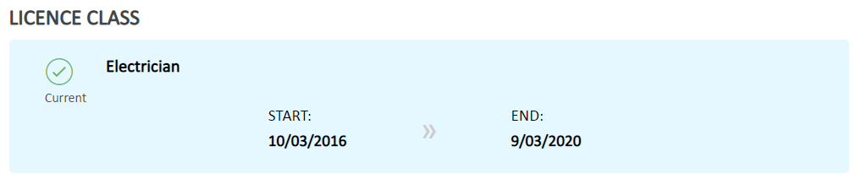 | M | Principal | Completed
 | List the tanks and pits on a site confined space register.  Safety & Wellness BP will assist to complete this in conjunction with GA | M | GA & SWBP | 6/6/19
 | Engage contractors trained in confined spaces entry to perform any work required in confined spaces. Only allow entry after a risk assessment and entry permit is completed and required precautions (such as air quality monitoring and emergency rescue arrangements) have been implemented. Display “confined space – entry by permit only” signage prior to opening confined spaces.  Bob, I need to discuss this with you as this relates only to contractors (i.e. no CDMN employee enters or works in confined spaces) – new Confined Spaces Procedure to be introduced. | M | Principal
 | Remove unused and excessive quantities of chemicals from the site. Then maintain accurate Chemical Register to ensure that all hazardous and / or dangerous chemicals held on site are placed on the register, including their storage locations and maximum quantities held on site.  Safety & Wellness BP will assist to complete this in conjunction with those areas where chemicals are stored and used. New Chemical Management Procedure to be introduced.  - TAS – Cherie Borger  - Science – Helena Slee (Kitley)  - GA – Tony Fraser  - Cleaners – Debra Punshon  Emailed Helena Kitley 23/5/19 to schedule meeting on 3/6/19 | M | TAS & Science Faculties  GA  Cleaners | 3/6/19
 | Conduct risk assessments for all hazardous chemicals that are used and stored within the school.  Keep SDS for all hazardous chemicals used and stored within the school.  Safety & Wellness BP will assist to complete this in conjunction with those areas where chemicals are stored and used. New Chemical Management Procedure to be introduced. | M | TAS & Science Faculties  GA  Cleaners | 3/6/19
 | Install a flammable liquids cabinet in the main maintenance / grounds area. Then insert all flammable liquids held by maintenance / grounds in the cabinet.  Need to confirm quantities of flammable liquids being stored – is there an opportunity to reduce the amount stored? If not, then a cabinet will need to be purchased. Risk assessment to be completed for use of spare room. | M | GA | 3/6/19
 | Restrain the LPG cylinders in a ventilated location away from ignition sources.  Conduct a risk assessment for the LPG storage and use.  Safety & Wellness BP will assist to complete this in conjunction with GA and TAS Faculty | M | GA  TAS Faculty | 3/6/19
 | Review the WHS HelpDesk open items at WHS Committee meetings each Term. | L | HSR
 | Conduct risk assessments on high risk day-to-day activities, including cleaner’s jobs, grounds / maintenance tasks, using electrical equipment or working at heights (e.g. cleaning gutters).  Safety & Wellness BP will assist to complete this in conjunction with those completing high risk tasks (i.e. GA, cleaners etc.)  GA have completed chainsaw training – need to ensure chainsaws are on Plant & Equipment Register | L | GA  Cleaners
 | Record communication of the school’s WHS Duty of Care Checklists at annual WHS re-induction sessions at the beginning of the school year. | L | Principal | Completed
 | Record emergency drills, including any corrective action opportunities to improve emergency response arrangements, in compliance with AS3745 Planning for emergencies in facilities.  Bob, I need to discuss this with you as the Safety & Wellness Team have developed a new form for recording emergency drills  Discuss with Carmel Wright AP | L | Principal
 | Display copies of the First Aid Officers’ current First Aid Certificates in the Sick Bay.  Keep records of first aid room / kit inspections to confirm that the required inspection has been completed and the necessary stock of products is in place.  - Christine Ausburn  - Catherine Edman  - Kylie Deverell | L | First Aiders
 | Enforce that all staff complete the now overdue Duty of Care in Australian Workplaces training that was due by 06/07/18.  Completed in OnGuard | L | Principal | Completed
 | Keep records of Working with Children Clearance Certificates for all contractors that work unescorted on site.  Check that builders and electricians used at the school hold current licences. This can be done via the following NSW Government website: https://www.onegov.nsw.gov.au/publicregister/#/publicregister/search/Trades  Contractor records maintained by Julie Barnes. Contractors complete an online induction before attending St Pius – Tony Fraser completed manual induction for any contractors who do not complete the online induction | L | Principal | Completed
 | Display the SafeWork Australia Notifiable Incident Fact Sheet on the staff WHS notice board and follow if required. The fact sheet can be downloaded from: https://www.safeworkaustralia.gov.au/doc/incident-notification-fact-sheet  Emailed to Mark Pearce 24/5/19 | L | HSR
 | Document a school WHS Consultation Statement to formalise the HSR, WHS Committee and WHS component in Staff Meetings as the agreed WHS consultation arrangements.  Record the employees’ agreement with the WHS Consultation Statement at a Staff Meeting. | L | HSR
 | Keep records of WHS Committee training for the committee members. | L | Principal
 | Display the CSO’s Visitor Safety Rules and / or the school’s Parent / Carer / Visitor Safety Tips adjacent to the visitor sign in location.  Visitor safety rules are available in Compass – check with Julie Barnes | L | Administration Desk
 | Display a current SafeWork NSW “If You Get Injured at Work” poster in the staff room. Fill in the sections at the base to communicate details of Catholic Church Insurances and CSO’s Return-to-Work Coordinators. This poster can be downloaded from: http://www.safework.nsw.gov.au/__data/assets/pdf_file/0003/50088/SIRA08088-0217-358067_2017-version.pdf  Bob, I can print and bring a copy of this to my next visit – emailed to Mark Pearce 24/5/19 | L | HSR
 | Maintain a file to keep records of 6 monthly testing of emergency equipment, exit signs and emergency lights (the last report on file was from September 2016).  Completed by Guardian – need to check that this is included in the WHS Activities Calendar | L | Principal | Completed
 | Arrange workstation ergonomic assessments for workers that spend most of their working day using a screen-based workstation that have not previously been assessed.  Bob, I have a checklist that I can email to you for distribution to relevant persons – emailed 24/5/19 | L | Principal
 | Update the OnGuard manual handling and ergonomics training in the next year.  Check with Peter Roberts that this is now available in ESN | L | Principal
 | Record noise assessments for noisy cleaners and grounds workers’ equipment that is used by operators for long periods each week (like vacuums and mowers).  Safety & Wellness BP can assist with this as the team have a noise monitor. Consider St Pius for bench marking activity. | L | GA & Cleaners
 | Update the school’s Electrical Safety Management Policy and Procedures to change references from “WHS Regulations 2011” to “WHS Regulation 2017”.  Recommend using the CSO Policy and Procedures from the CSO Intranet | L | Principal
 | Maintain records of registration for plant (e.g. lifts and large pressure vessels) on site requiring registration.  Safety & Wellness BP can assist to complete this in conjunction with key personnel (i.e. GA, TAS etc.) and ensure Plant & Equipment Register is completed  There are two lifts operational and one non-operational – regular inspections completed by OTIS | L | Principal
 | Inspect playground and sports equipment as part of workplace inspections that are scheduled to be completed each term.  Bob, there is a checklist for this – just needs to be assigned to the right person(s) – WHS Committee | L | Principal

Workplace Observations
The following were identified during our workplace observations:
Minerva’s Physical Opportunities for Improvement Action Plan for St Pius X High School, Adamstown
# | Location | Recommendations | Photo | Priority | Person Responsible | Scheduled Completion Date | Actual Completion Date/Sign Off
 | Old Grounds Shed | Remove the flammable aerosol cans from next to ignition / heat generating sources (cooking appliances). | 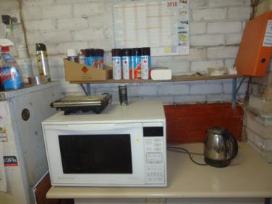 | H | GA | Completed
 | Hospitality Class Room | Fix the damaged electrical power point. | 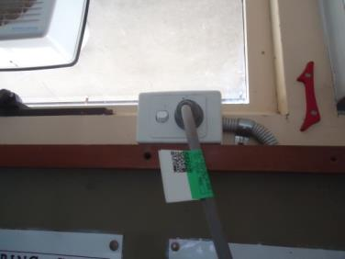  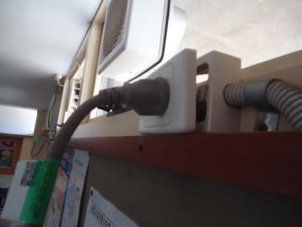 | H | GA | Completed
 | Staff Rooms | Keep the hot water system clear of chemicals, flammable and combustible materials. | 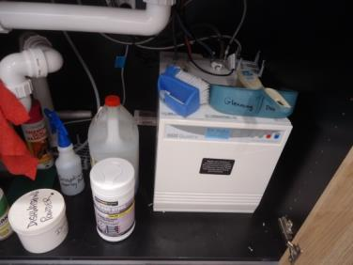  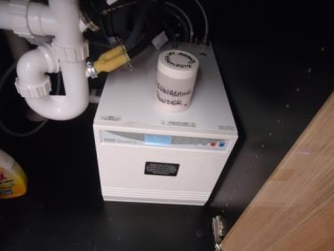  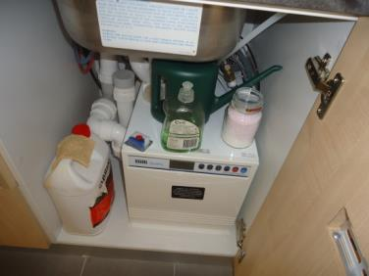  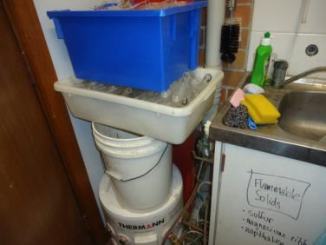  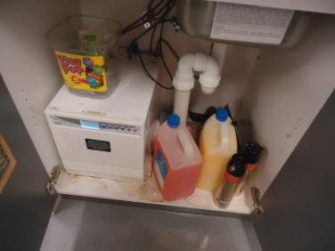 | H | Principal
 | TAS | Move the flammable liquids cabinet 3 metres away from the electrical distribution board and potentially heat / spark generating power tools.  Provide clear access to the electrical distribution board so it can be easily accessed in an emergency. | 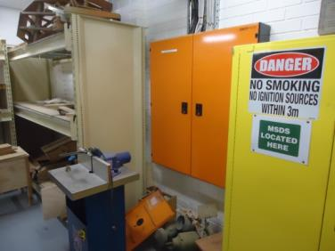 | H | Head of TAS Faculty – Cherie Borger
 | TAS | Cease storing the heavy stone upright where it could fall onto a person. | 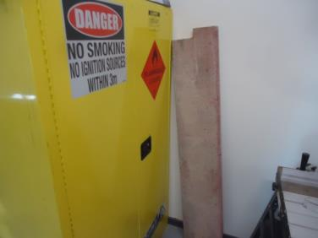 | H | Head of TAS Faculty – Cherie Borger
 | Throughout School | Train teachers and staff to keep a 1 metre clearance zone around fire extinguishers and blankets so they can be easily accessed in an emergency. Bob, I can easily prepare a safety memo for this is not already completed  Improve supervision of the fire equipment contractor to make sure that all fire extinguishers and fire blankets undergo 6 monthly inspections and tagging. Completed by Guardian. | 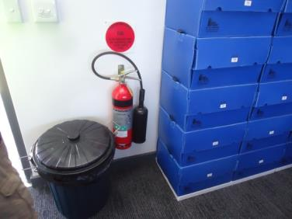  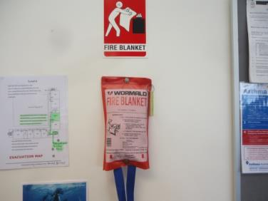  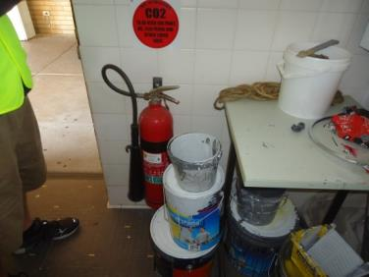  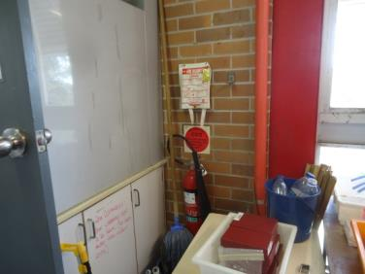  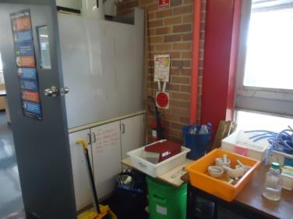  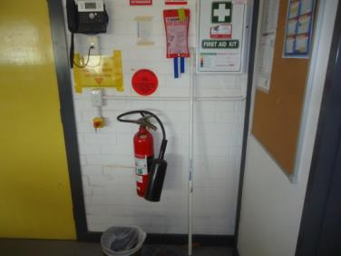  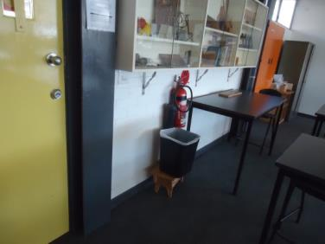  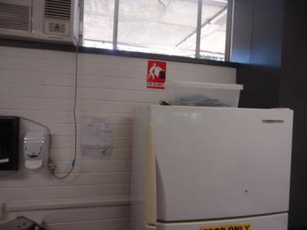  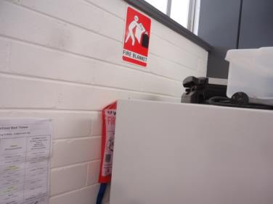 | M | Principal
 | Throughout School | Review the style of fire hose reel cabinets as many cabinets are missing their keys so they cannot be easily opened. Make sure the keys are in place and simple to use so the fire hose reels can be easily accessed in an emergency.  Can these be left unlocked? Discussed with Tony and he will remove keys and purchase latches to keep the doors closed (no locks) | 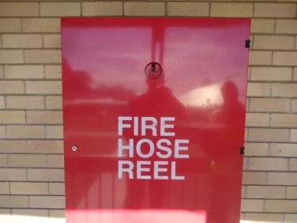 | M | HSR and GA
 | Throughout School | Check that all emergency exit lights are illuminated at all times and that 6 monthly testing is conducted.  Completed by Guardian | 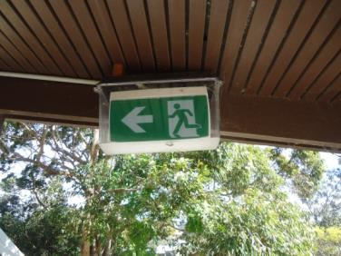 | M | Principal | Completed
 | Throughout School | Check that all electrical appliances and leads used in hostile environments are tested and tagged annually.  Check that all electrical appliances and leads used in workshops and for commercial cleaning are tested and tagged 6 monthly.  Bob, there is a new Electrical Testing & Tagging Procedure which I emailed to you for review | 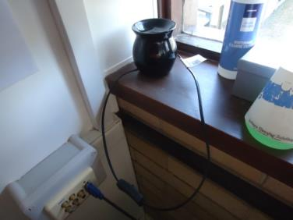  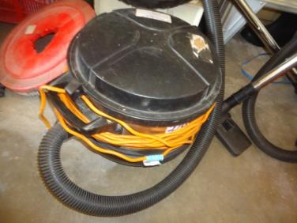  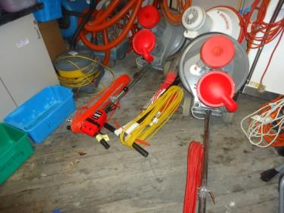  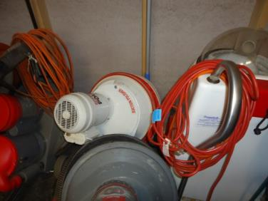  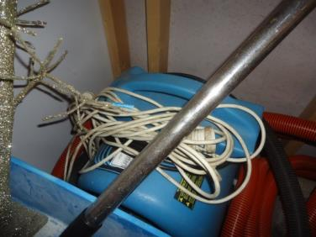  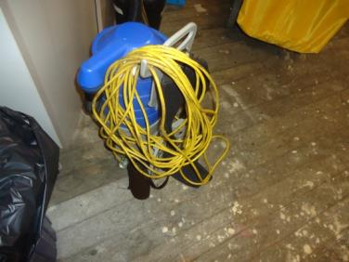  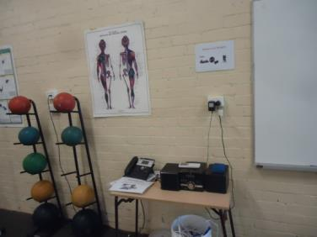  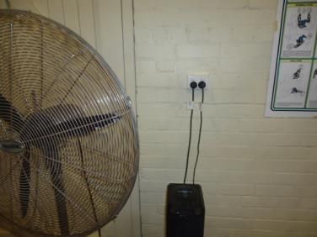  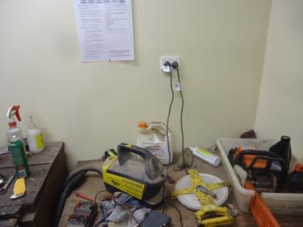  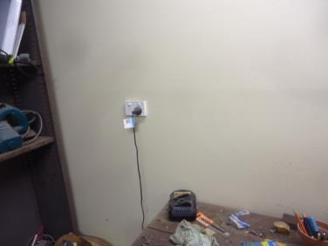  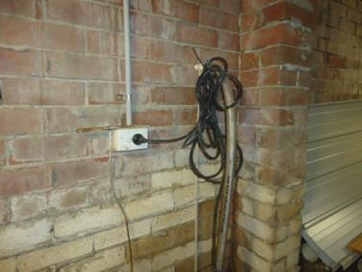  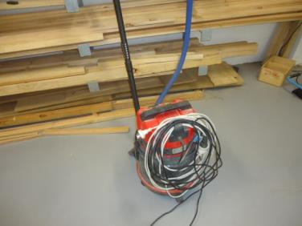  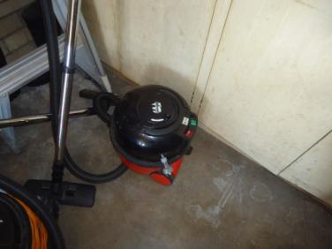 | M | Principal
 | Throughout School | Secure electrical power boards to walls so their pin holes are in a vertical plain to minimise the risk of liquid or dust falling into the pin holes and connections separating.  Tony to check all areas of the school to ensure power boards are located in safe areas and, where necessary, secure to wall | 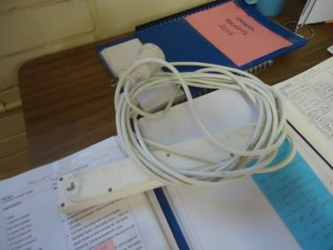  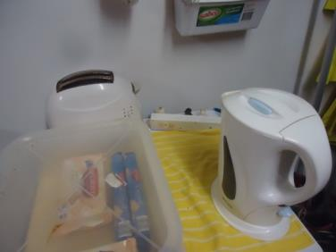  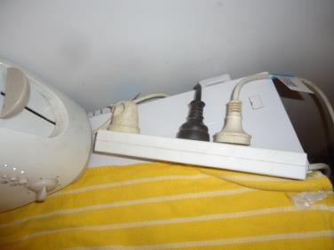  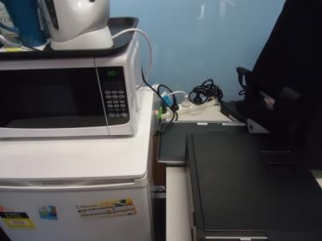  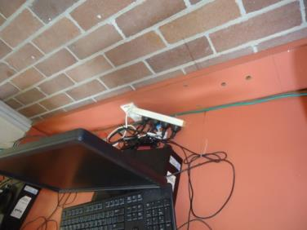  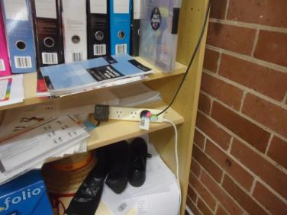  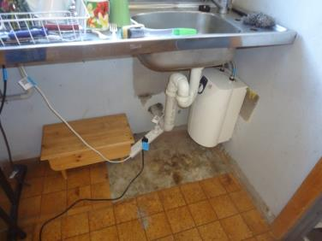 | M | GA
 | Throughout School | Develop a confined spaces register that lists the tanks and pits within the school that are large enough to need a person to enter to maintain or clear blockages or repair pumps.  Safety & Wellness BP can complete this in conjunction with GA. To be completed 6/6/19. | 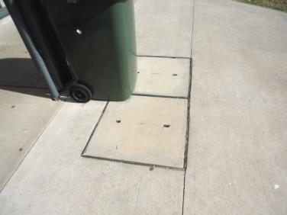  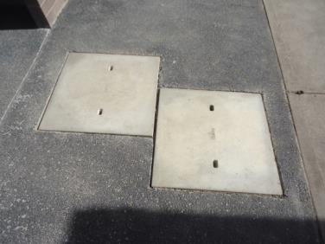  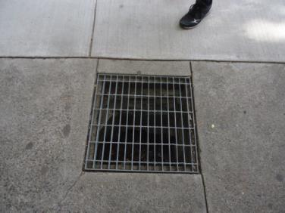  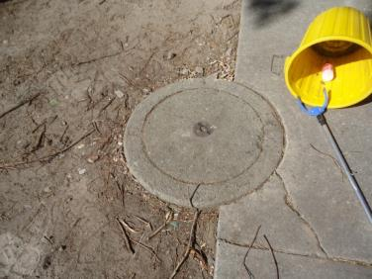  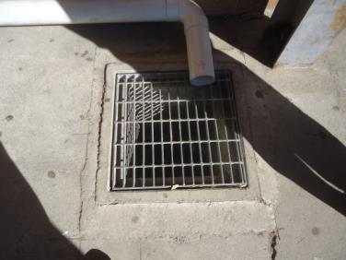  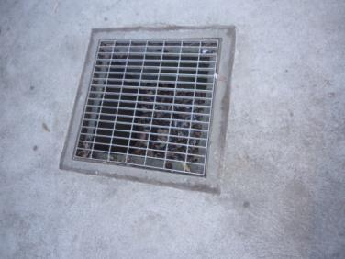  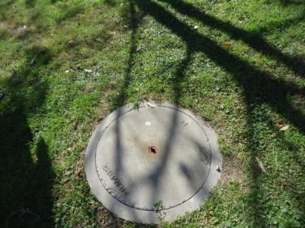  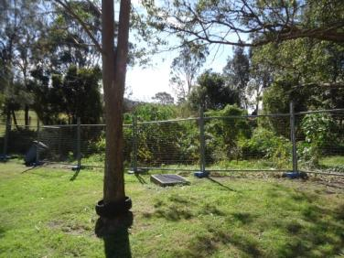 | M | GA | 6/6/19
 | Throughout School | Check that all chemical containers are clearly and legibly labelled, including emergency / first aid information, warnings and hazardous chemical symbols (labels can be printed off ChemWatch – naming the contents in texta is not sufficient for hazardous chemicals). Replace damaged and faded labels. | 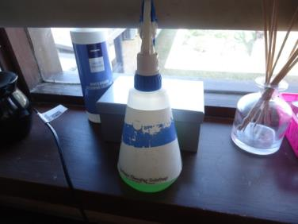  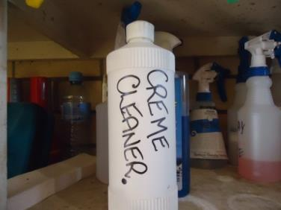  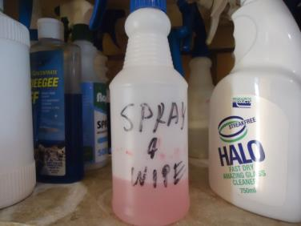  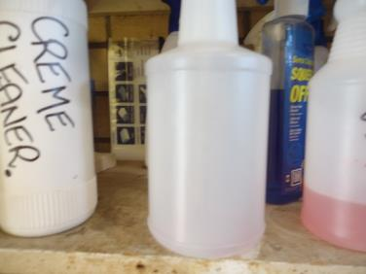  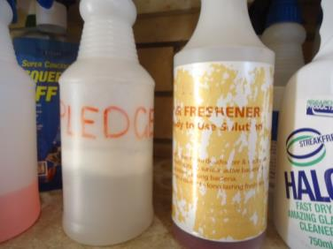  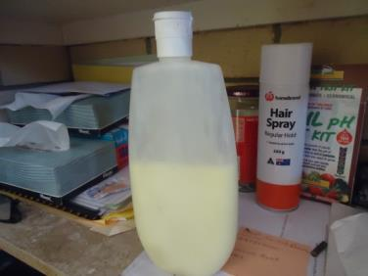  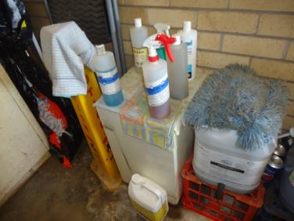  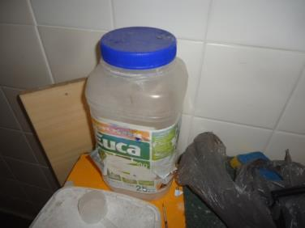  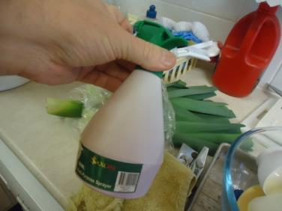  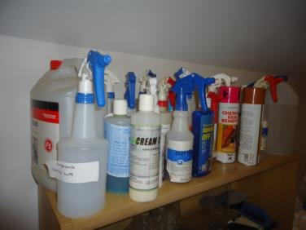  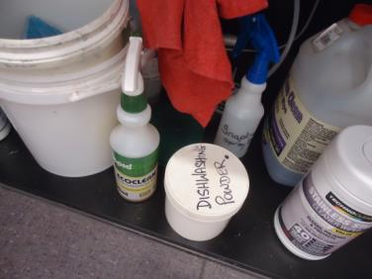  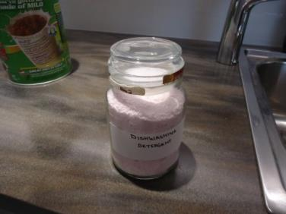  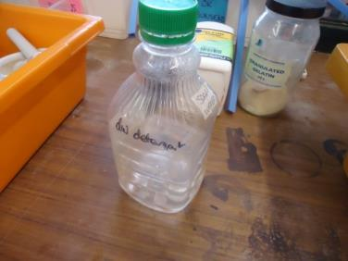  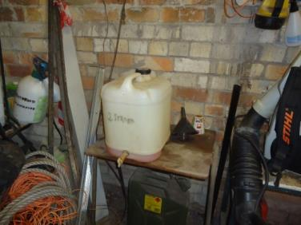  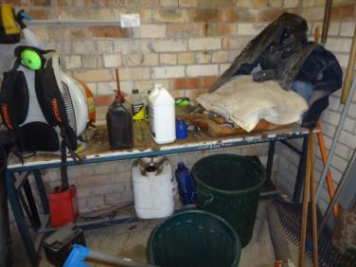  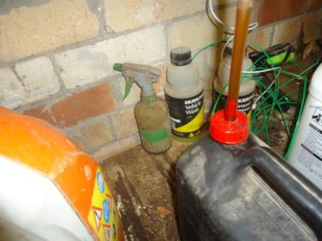  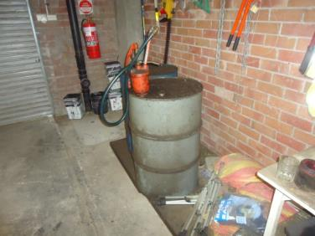  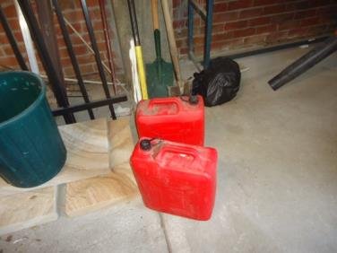  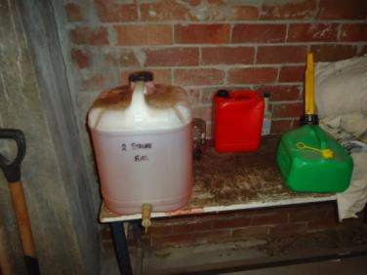  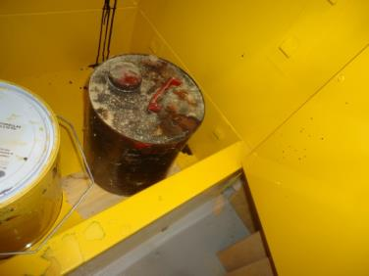  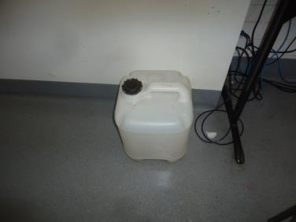  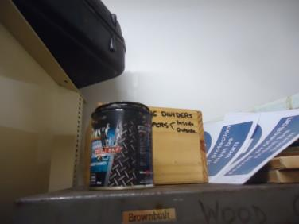 | M | Principal
 | Throughout School | Remove the un-needed / perished chemicals from site and minimise the hazardous chemicals stored on site. Supervise that hazardous chemicals are not ordered in excessive quantities. For the hazardous chemicals that are retained, accurately list them on the Hazardous Chemicals Register.  Bob, I can help with this – first step is for the keepers of the chemicals to review what they have and discard old/unused chemicals (i.e. less is best) – I can then work with area individuals to complete registers | 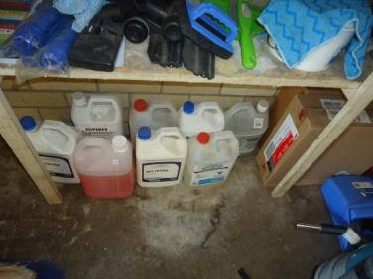  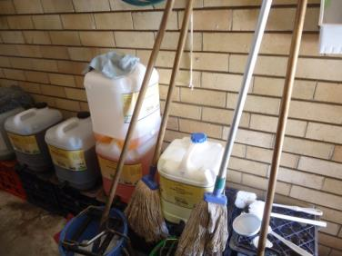  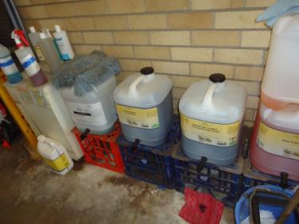  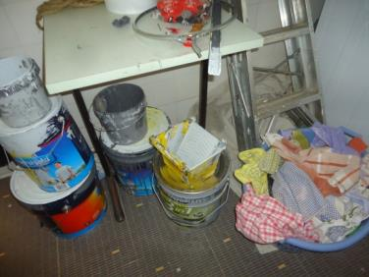  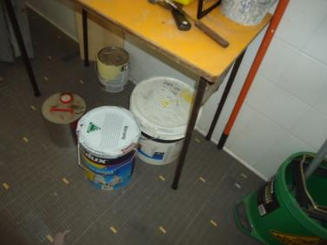  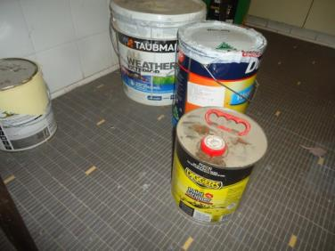  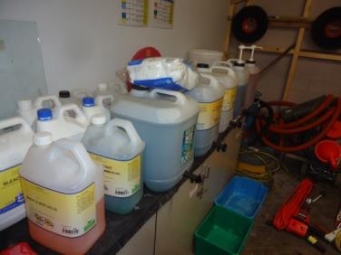  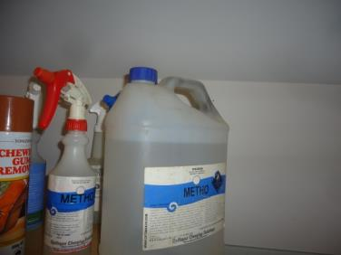  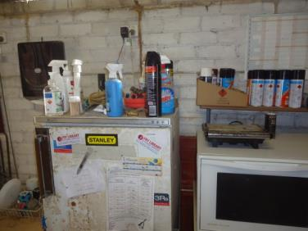  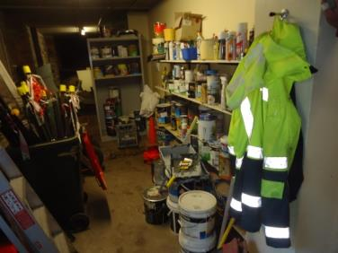  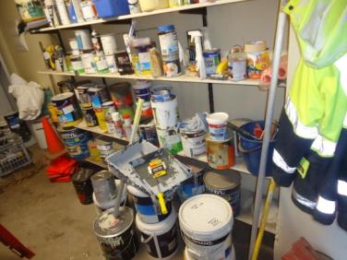  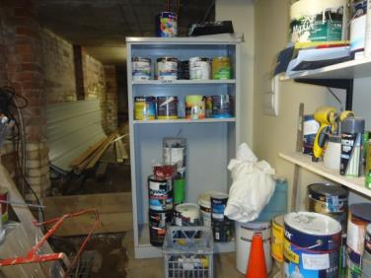  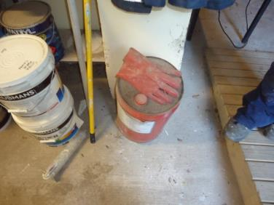  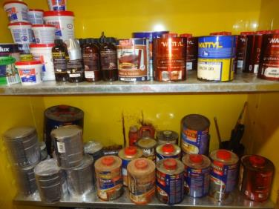  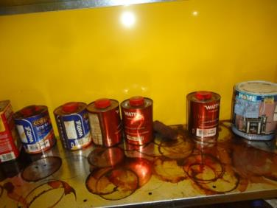  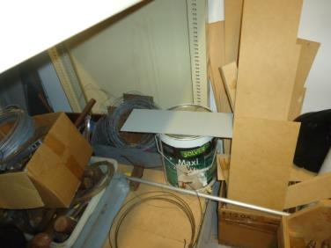  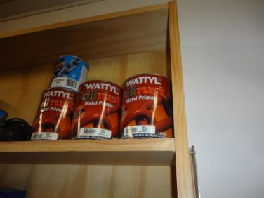  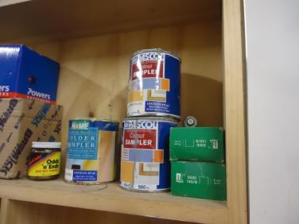 | M | Principal
 | Throughout School | Never store chemicals in former food or drink containers.  All substances stored in food containers need to be removed and disposed of if not already done | 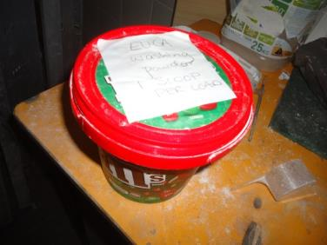  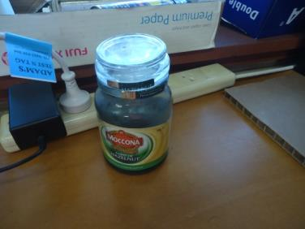  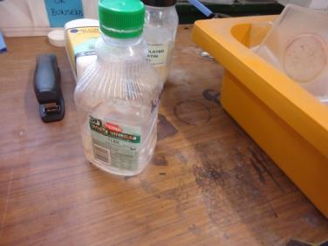  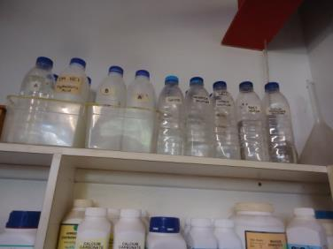  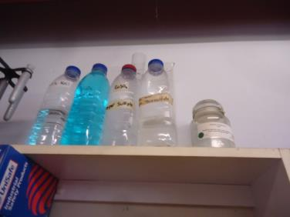  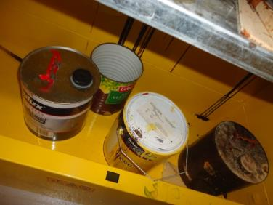  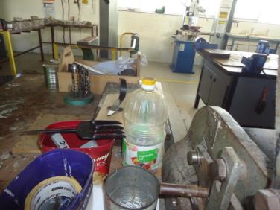 | M | Principal
 | Throughout School | Update out-of-date hard copy safety data sheets (must be the manufacturer / suppliers’ latest version and less than five years’ old).  These can be obtained from ChemWatch or manufacturer’s website – Safety & Wellness BP can assist with providing guidance on this to those individuals in charge of chemicals | 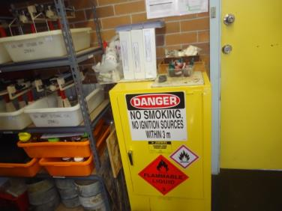  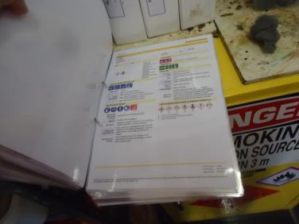 | M | Principal
 | Throughout School | Cease storing chemicals in the bund of flammable liquids cabinets so this area is empty to contain any spills in accordance with the cabinets’ design / purpose.  Safety & Wellness BP can assist with providing guidance on this to those individuals in charge of chemicals | 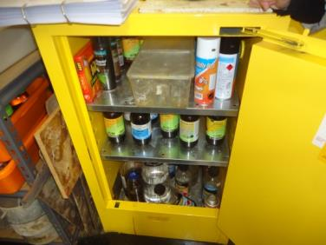  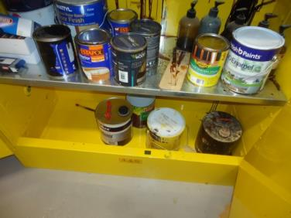  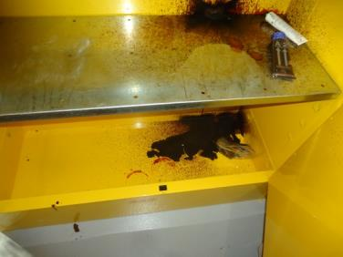 | M | Principal
 | Barbeque Area | Restrain the LPG cylinders in a ventilated location away from ignition sources.  Safety & Wellness BP can assist with providing guidance on this to those individuals in charge of the LPG cylinders – where possible reduce quantity stored (i.e. just have one for each BBQ) – where there are multiple a storage cage is recommended (I can provide information on where to obtain) | 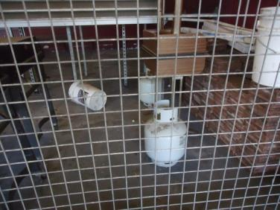 | M | GA
 | Above New Staff Room | Lock the window so people can’t access the roof without authorisation.  Install latch lock | 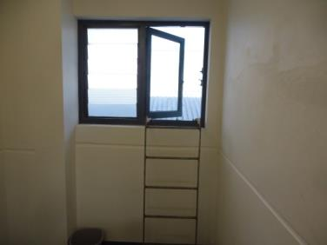 | M | GA
 | TAS | Restrain the LPG cylinders in a ventilated location away from ignition sources. | 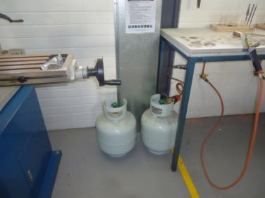 | M | Head of TAS Faculty – Cherie Borger
 | Science and TAS Rooms | Install emergency eye wash and shower signage above emergency eye washes and showers.  Maintain clear access to emergency eye washes and showers so they can be easily accessed in an emergency (including people that cannot see if splashed in the eyes). | 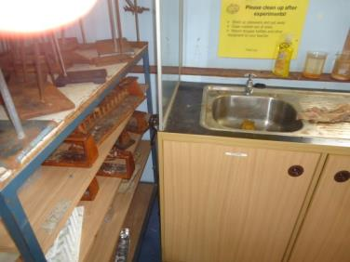  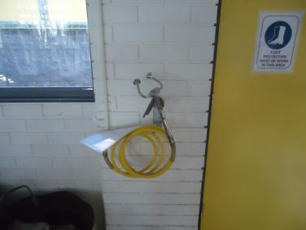 | M | Heads of Science & TAS Faculties – Cherie Borger and David Millen
 | Canteen | Remove piggy back style double adapters from the workplace. | 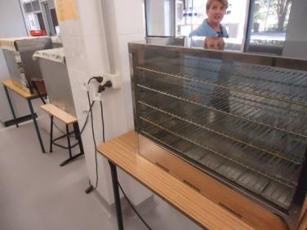 | M | GA
 | Canteen | Review electrical arrangements in the Canteen to provide power points where needed without cords / connections needing to hang unsupported under tension. | 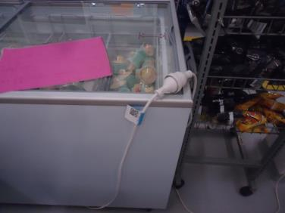  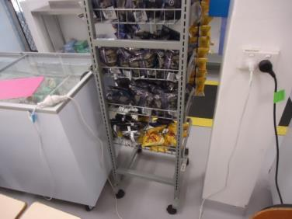 | M | GA
 | Canteen | Remove the lock from the cool room so a person cannot be locked inside. | 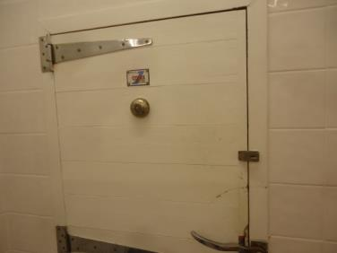  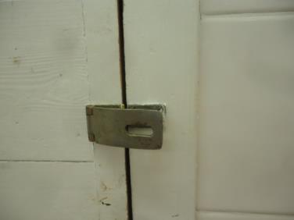 | M | GA
 | Throughout School | Check that all first aid kits are inspected, restocked and tagged 6 monthly.  Safety & Wellness BP can provide guidance on this to first aiders. | 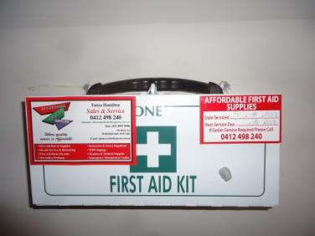 | L | First Aiders
 | Science Rooms | Remove the “first aid” stations if they are not maintained with saline nebules.  Safety & Wellness BP can provide guidance on this to first aiders. | 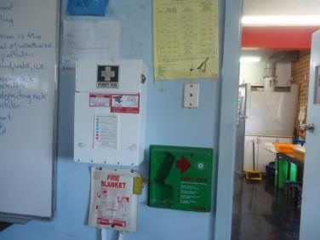  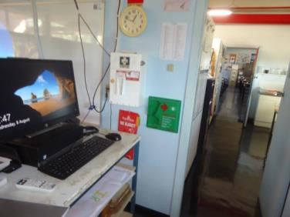 | L | First Aiders
 | Gymnasium | Conduct a risk assessment to determine the safety of the old gym equipment as it was showing signs of corrosion and wear.  Need to review this in conjunction with Peter Roberts, Safety & Wellness Team Leader  Contact John McLoughlin and John Pryor | 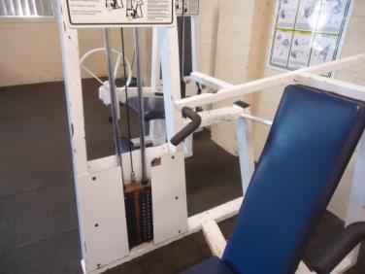  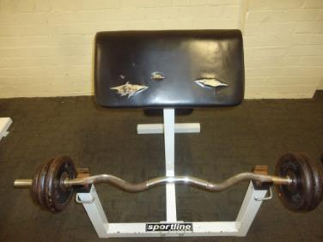  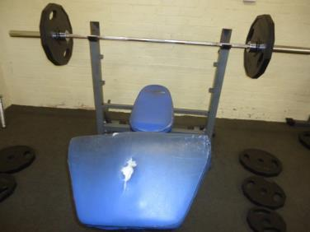  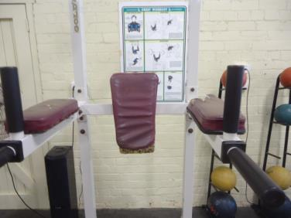 | L | Principal

